1. Copy **Shipment_Charges_Gain_Loss_3.zip** from **00-c-import** folder to your **C:\** directory, then unzip it. You can skip this step if already done.

Copy zip file.

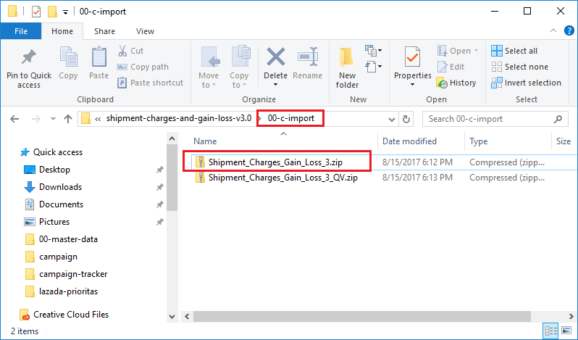

Paste to C:\ directory, right click, then press open.

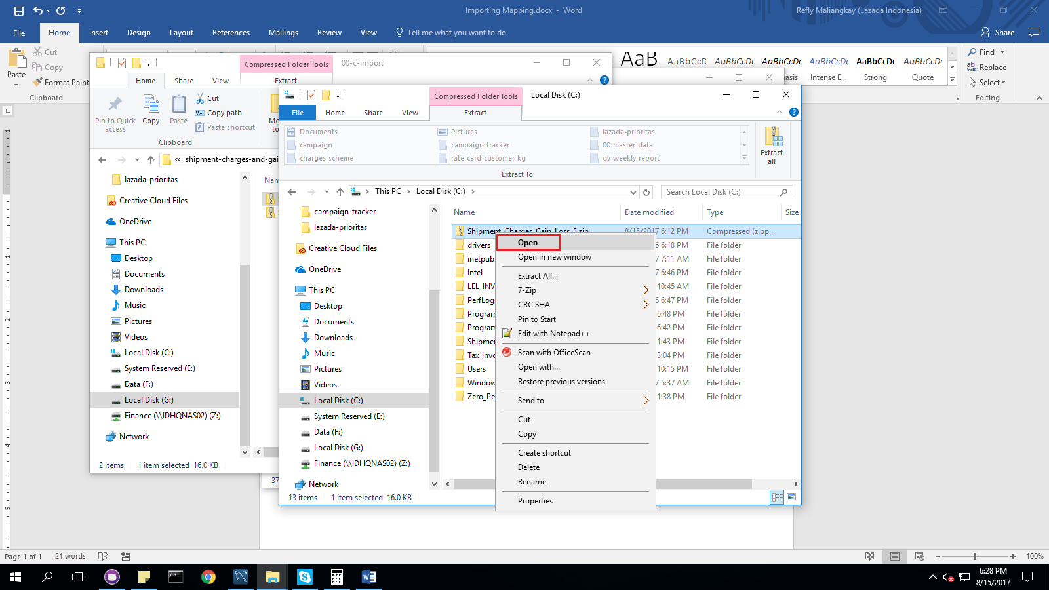

Copy the folder inside the zip file.

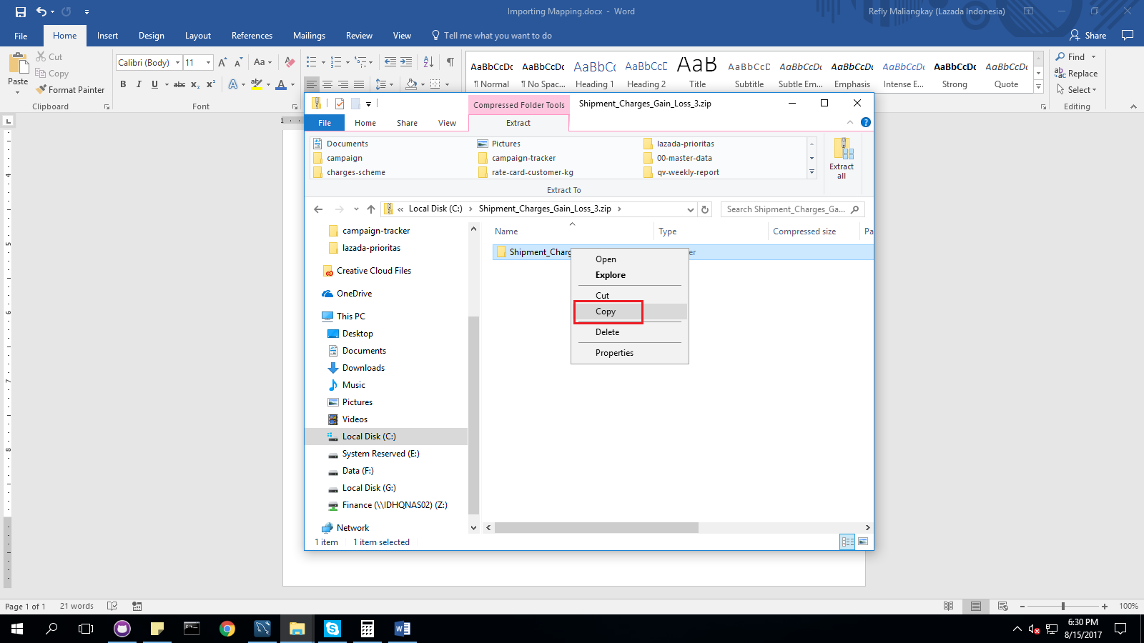

Go back to your C:\ directory then paste it.

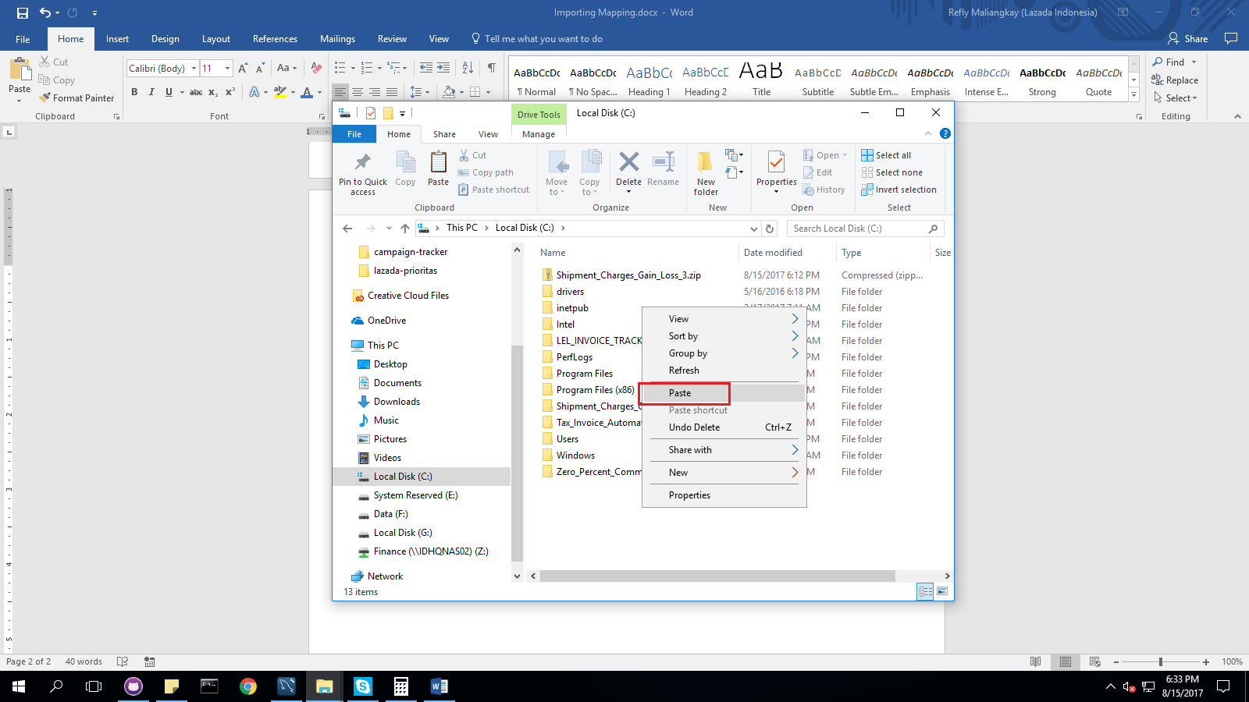

1. Go inside folder **C:\Shipment_Charges_Gain_Loss_3\_UPDATE**, make sure the import batch file **UPDATE_ALL.bat** is present. Copy all folders and files from **00-master-data** folder into **C:\Shipment_Charges_Gain_Loss_3\_UPDATE** then run **UPDATE_ALL.bat**.

Go to C:\Shipment_Charges_Gain_Loss_3\_UPDATE.

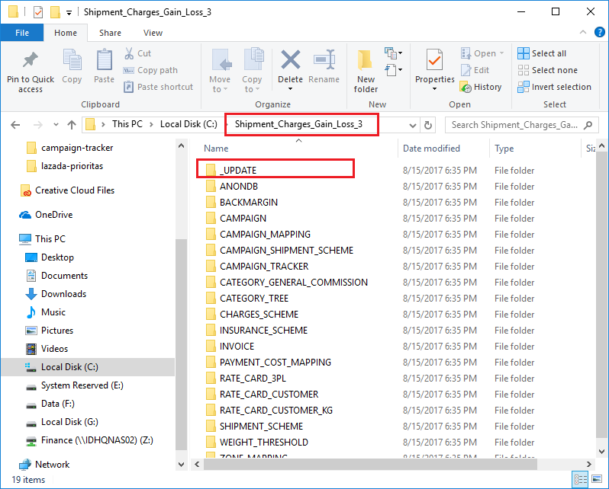

Check if UPDATE_ALL.bat present.

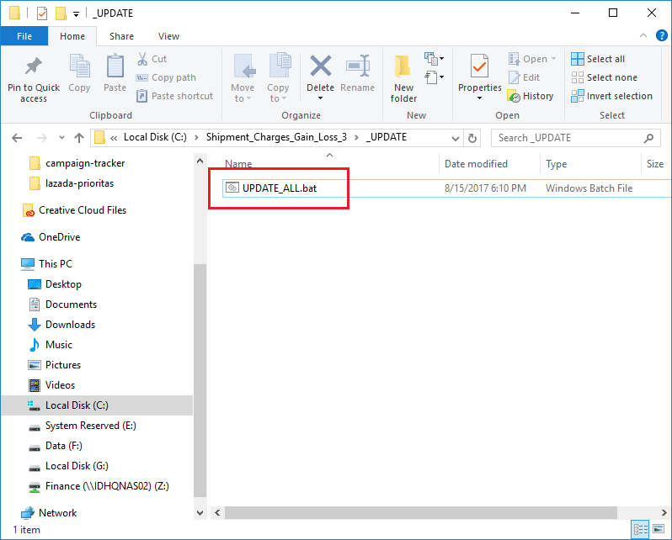

Copy all folders from 00-master-data.

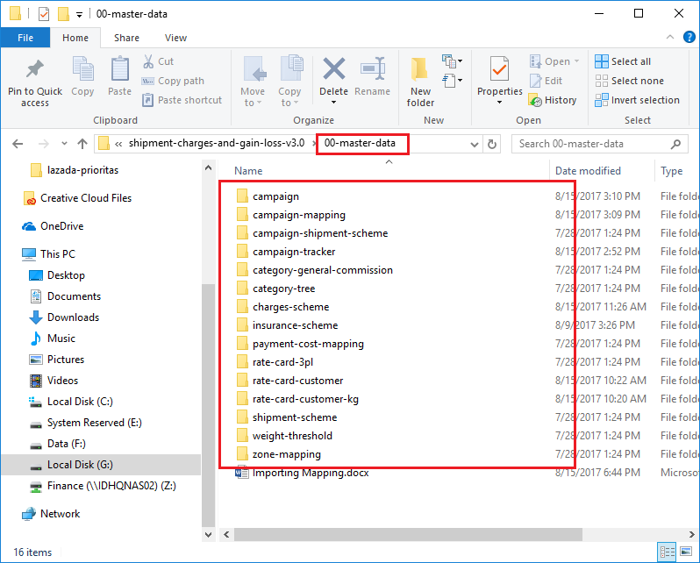

Paste them to C:\Shipment_Charges_Gain_Loss_3\_UPDATE folder.

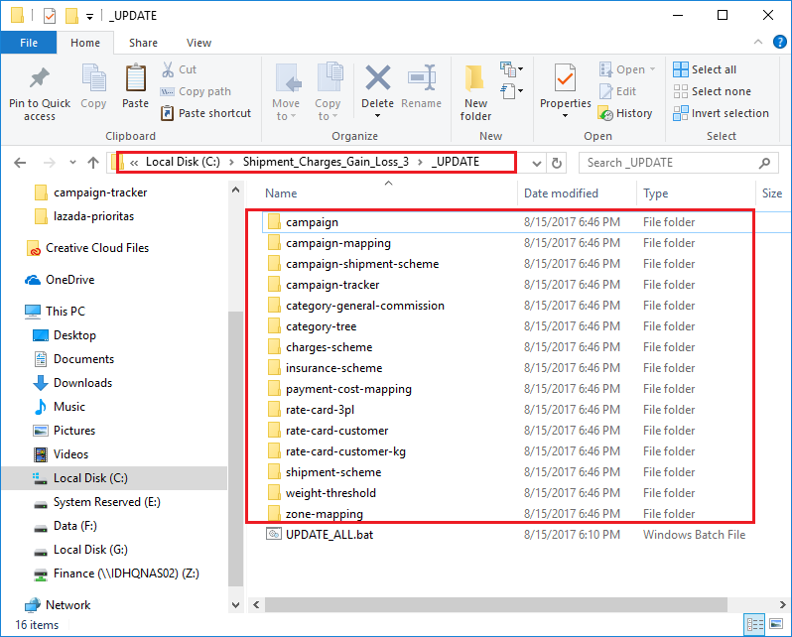

Run UPDATE_ALL.bat.

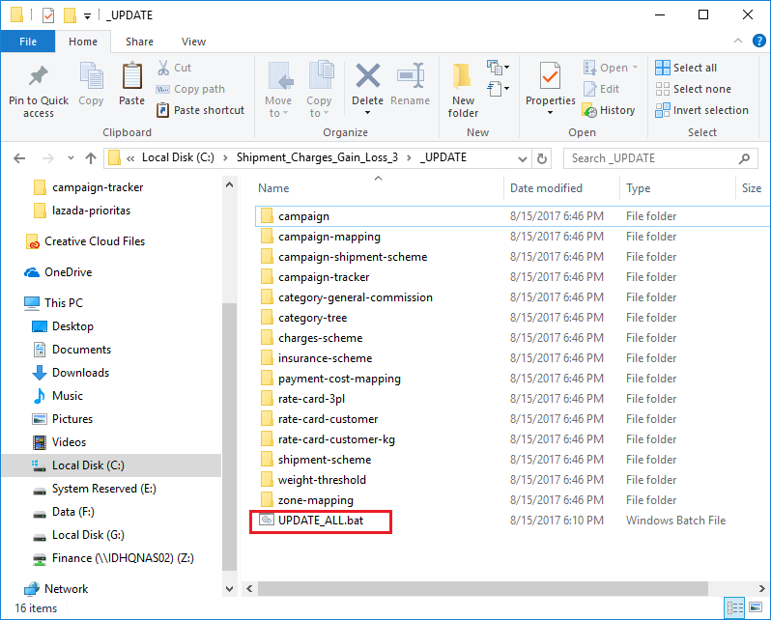

1. A command prompt screen will appear. Follow the instruction by pressing any key. Also, look at the command prompt screen if there’s any error.

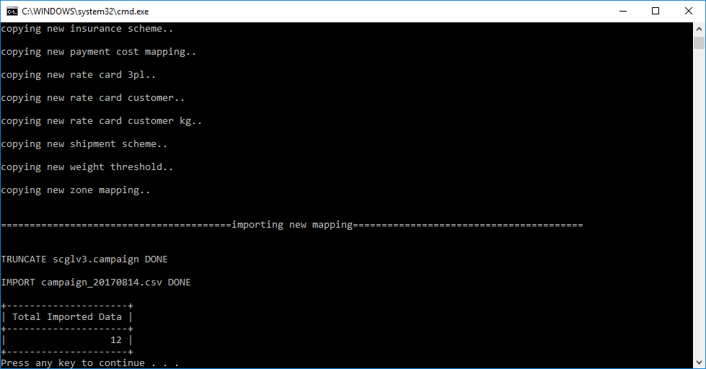

1. Delete all the mapping folders from **C:\Shipment_Charges_Gain_Loss_3\_UPDATE**. This must be done to prevent double/wrong upload to the database.



